
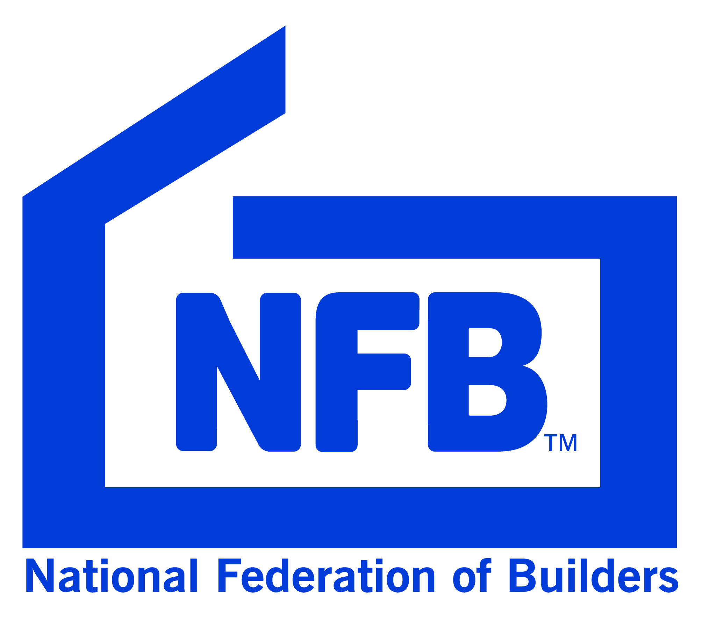

RIBA



Suffolk Joint Construction Committee
Awards & Charity Supper

Trinity Park Ipswich IP3 8HU

Thursday 16th May 2024
at 6.45pm

R I B A Suffolk will be presenting their annual
Craftsmanship and Design Awards
for projects completed
and
SJCC will be presenting the Building Trainee Awards

Suffolk Joint Construction Committee Annual Supper
Thursday 16th May 2024
6.45pm for 7.30pm

Trinity Park, Felixstowe Road, Ipswich, IP3 8UH

Company:
Address:
Postcode:
Telephone No:
Fax No:
E mail:
Office Contact:
Special Dietary Requirements:

Please reserve………places at £75.00 per person
(This includes a £5 donation to the Ipswich Rotary charity)

BACS Sort Code:30-94-55 Account Number: 00604691 (preferred method of payment)

Alternatively, I enclose a cheque for £………..made payable to “Suffolk Joint Construction Committee”

Please return as soon as possible
Post to: Joanne Williams, SJCC Supper, National Federation of Builders, Elizabeth House, 8A Princess Street, Knutsford, Cheshire, WA16 6DD

Telephone: 03450 578 160 E-mail: joanne.williams@builders.org.uk

